**Title †**

**Firstname Lastname 1, Firstname Lastname 2 and Firstname Lastname 2,\***

1Affiliation 1

2Affiliation 2

*Correspondence: e-mail@e-mail.com; Tel.: (optional; include country code; if there are multiple corre-sponding authors, add author initials)

†Presented at the title, place, and date.

**Abstract:** A single paragraph of about 100 words to give a brief introduction to your work.

**Keywords:** keyword 1; keyword 2; keyword 3; keyword 4; keyword 5

**1. Introduction**

The introduction should briefly place the study in a broad context and define the purpose of the work and its significance.

For papers that report original research, you should use the titles “Materials and Methods”, “Results”, “Discussion” and “Conclusions” (optional).

**2. Experimental**

Main text paragraph (M_Text).

Main text paragraph (M_Text).

**3. Results and Discussion**

Main text paragraph (M_Text).

*3.1. Subsection*

3.1.1. Subsubsection

Bulleted lists look like this:

• First bullet;

• Second bullet;

• Third bullet.

Numbered lists can be added as follows:

1. First item;

2. Second item;

3. Third item.

The text continues here.

*3.2. Figures, Tables and Schemes*

All figures and tables should be cited in the main text as Figure 1, Table 1, etc.

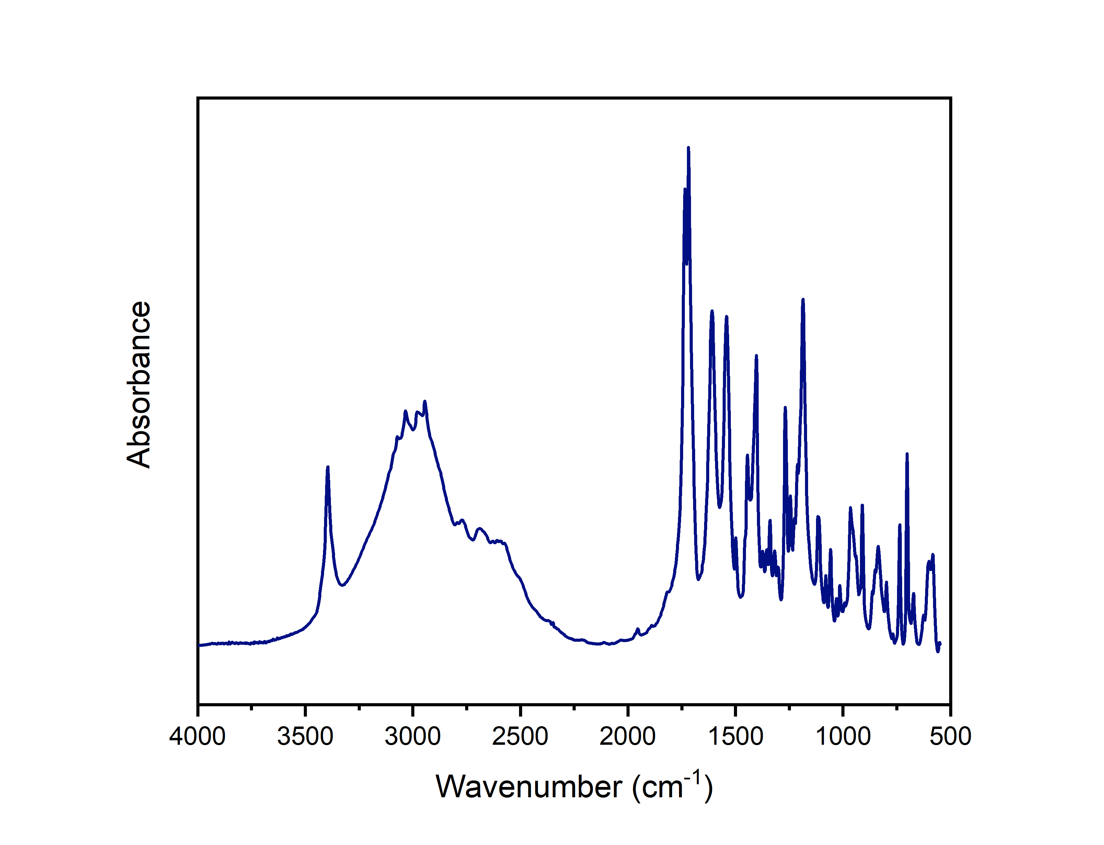

**Figure 1.** This is a figure.

**Table 1.** This is a table. Tables should be placed in the main text near to the first time they are cited.

|  |  |  |
| --- | --- | --- |
| **Title 1** | **Title 2** | **Title 3** |
| Entry 1 | data | data |
| Entry 2 | data | data 1 |

1 Tables may have a footer.

**Scheme I**

Scheme is placed in the center of the paper without any scheme caption.

*3.3. Formatting of Mathematical Components*

This is example 1 of an equation:

a = 1, (1)

The text following an equation need not be a new paragraph. Please punctuate equations as regular text.

This is example 2 of an equation:

a = b + c (2)

The text following an equation need not be a new paragraph. Please punctuate equations as regular text.

**Author Contributions:** For research articles with several authors, a short paragraph specifying their individual contributions must be provided. The following statements should be used “Conceptualization, X.X. and Y.Y.; methodology, X.X.; software, X.X.; validation, X.X., Y.Y. and Z.Z.; formal analysis, X.X.; investigation, X.X.; resources, X.X.; data curation, X.X.; writ-ing—original draft preparation, X.X.; writing—review and editing, X.X.; visualization, X.X.; su-pervision, X.X.; project administration, X.X.; funding acquisition, Y.Y. All authors have read and agreed to the published version of the manuscript.” Please turn to the CRediT taxonomy for the term explanation. Authorship must be limited to those who have contributed substantially to the work reported.

**Funding:** Please add: “This research received no external funding” or “This research was funded by NAME OF FUNDER, grant number XXX” and “The APC was funded by XXX”. Check carefully that the details given are accurate and use the standard spelling of funding agency names at https://search.crossref.org/funding. Any errors may affect your future funding.

**Acknowledgments:** In this section, you can acknowledge any support given which is not covered by the author contribution or funding sections. This may include administrative and technical support, or donations in kind (e.g., materials used for experiments).

**Conflicts of Interest:** “The authors declare no conflict of interest.”

**References**

1. Author 1, A.B.; Author 2, C.D. Title of the article. Abbreviated Journal Name Year, Volume, page range.
2. Author 1, A.; Author 2, B. Title of the chapter. In Book Title, 2nd ed.; Editor 1, A., Editor 2, B., Eds.; Publisher: Publisher Location, Country, 2007; Volume 3, pp. 154–196.
3. Author 1, A.; Author 2, B. Book Title, 3rd ed.; Publisher: Publisher Location, Country, 2008; pp. 154–196.
4. Author 1, A.B.; Author 2, C. Title of Unpublished Work. Abbreviated Journal Name year, phrase indicating stage of publication (submitted; accepted; in press).
5. Author 1, A.B. (University, City, State, Country); Author 2, C. (Institute, City, State, Country). Personal communication, 2012.
6. Author 1, A.B.; Author 2, C.D.; Author 3, E.F. Title of Presentation. In Proceedings of the Name of the Conference, Location of Conference, Country, Date of Conference (Day Month Year).
7. Author 1, A.B. Title of Thesis. Level of Thesis, Degree-Granting University, Location of University, Date of Completion.
8. Title of Site. Available online: URL (accessed on Day Month Year).